9th September 2024

*\* The Town Council invites members of the public to ask questions or raise issues relevant to the work of the Council. The overall time available for this session is restricted to 15 minutes unless the Chairperson decides otherwise.* ***Please note:*** *questions to be submitted in writing, to arrive via email at the Council Office* ***by 12 noon on the day of this meeting****.*

Dear Councillor,

You are hereby summoned to attend a meeting of Bovey Tracey Town Council on **Monday 16th September 2024** at **7.00pm** at **Heathfield Community Centre** for the purpose of transacting the business as set out on the agenda below.

**AGENDA**

**FC.24/40 Apologies for absence**

To **receive** apologies for inability to attend.

**FC*.*24/41Declarations of Interest and Requests for Dispensations**

To **declare** any disclosable pecuniary interests or any other interest which members may have in the following agenda items and **consider** any dispensation requests.

**FC.24/42 Minutes**

i) To **receive** and **resolve** as a correct record the minutes of the Council meeting held on 24.06.24 *(*[*\*copy enclosed*](https://www.dropbox.com/scl/fi/w7bkg75ktty0nfbm5tpvx/16.09.24-DRAFT-Full-Council-minutes-of-24.06.24.docx?rlkey=906czci1k04f515gx8raeub43&dl=0)*).*

ii) To **receive** any update on any matters arising from the previous Council meeting (if any).

**FC.24/43 Standing Item – Climate and Ecology Emergencies:**

To **note** the Council Declaration and to embed the Climate and Ecology Emergency Declaration across all Council services, activities, plans and other relevant work, considering the environmental impact of decisions, ensuring a fully integrated approach to mitigating the impact of climate change.

***The meeting will go out of session***

**FC.24/44** **Reports from Key Bodies on Parish related matters:**

To **receive** reports (*if received*) from key bodies including:

i) Chaplain to the Council

ii) Police ([*\*copy enclosed*](https://www.dropbox.com/scl/fi/uqlga2sfjbeyspckos0uj/16.09.24-Devon-and-COrnwall-Police-Report-Sept-2024.pdf?rlkey=p0unqgrqlk9erdelfhq3n18dj&dl=0))

iii) Devon County Councillor (Cllr Gribble)

Teignbridge District Councillors (Cllrs Morgan, Smith ([*\*copy enclosed*](https://www.dropbox.com/scl/fi/ncq8eo4q1w8v86n5yxwfr/16.09.24-Report-to-Bovey-Tracey-Town-Council-Cllr-Martin-Smith-Sept-2024.pdf?rlkey=91ss5f9b61cp7mc3qwjw4b6aw&dl=0)) and Webster)

iv) Town Mayors Interests ([*\*copy enclosed*](https://www.dropbox.com/scl/fi/li4wfpg6e5pmgqqmjs40k/16.09.24-Town-Mayors-Activities-June-September-2024.pdf?rlkey=8d73ou6vahtu83fsk7q45rfp1&dl=0))

v) Other outside bodies or interests (all Councillors)

- Heritage Society Committee Meeting Notes ([*\*copy enclosed*](https://www.dropbox.com/scl/fi/dx97z4f274ohsp5zxvnxr/16.09.24-Heritage-Society-Committee-Meeting-Notes-20th-August-2024.pdf?rlkey=z53l11qdwyvguf7yfky7mthjh&dl=0))

- Restoring Stover Park Project Plan ([*\*copy enclosed*](https://www.dropbox.com/scl/fi/sgxm8h3vgn2d76kcbreox/16.09.24-Restoring-Stover-Park-Project-Plan-Year-2-Quarter-2.pdf?rlkey=kp0ubiiyma9twljq6hx2br1w3&dl=0))

- Restoring Stover Park Meeting Minutes ([*\*copy enclosed*](https://www.dropbox.com/scl/fi/xk39gq0z9citqounk1etg/16.09.24-Restoring-Stover-Park-Meeting-Minutes-10th-July.pdf?rlkey=jty72ar8vydcfozgzykons8tp&dl=0))

- OPCC Councillor Advocate Meeting Notes ([*\*copy enclosed*](https://www.dropbox.com/scl/fi/ss3mvnwxe6pxpyanexpsy/16.09.24-OPCC-Meeting-Notes-04.09.24.docx?rlkey=yuz02hl8gmn9avk9nyjlah9l5&dl=0))

**FC.24/45** **Questions and Statements by the Public**

i) The Town Mayor will invite Members of the Public to give their views and question the Town Council on issues on this agenda, or raise issues for future consideration (*maximum 3 minutes per person*).

ii) The Town Mayor will invite brief, verbal presentations from candidate(s) in support of their application to the vacant Bovey Ward Councillor seat and invite any questions from members (*maximum 3 minutes per person*).

***The meeting will go back into session***

**FC.24/46 Business Raised by the Public:**

To **resolve** to refer any business raised by the public in public discussion and any other matters or items of information from Councillors, to the appropriate Committee or to resolve to agree on any other action.

**FC.24/47 Recreation, Parks & Property Committee (RP&P) Committee**:

To **receive** and **adopt** the minutes of the meeting held on 08.07.24 *(*[*\*draft copy*  *enclosed*](https://www.dropbox.com/scl/fi/rl8j6qlz8zosqaen9xacb/16.09.24-DRAFT-RP-P-Minutes-of-Meeting-held-on-08.07.24-v2.docx?rlkey=jtd5xm3ogbe7tpm6cuzkjf6vv&dl=0)*).*

**FC.24/48 Finance, Resources & General Purposes (FR&GP) Committee:**

i) To **receive** and **adopt** the minutes of the meeting held on 02.09.24 *(*[*\*draft copy enclosed*](https://www.dropbox.com/scl/fi/gceq5kfvcek03ybilaiaz/16.09.24-Draft-Minutes-of-FR-GP-Committee-Meeting-of-02.09.24.pdf?rlkey=tjh1h07g1a62atji7z8p9wmj7&dl=0)*).*

ii) To **consider** the following committee recommendations:

a) to **adopt** the revised CiL Groups Policy (FR&GP.24/56) ([*\*copy enclosed*](https://www.dropbox.com/scl/fi/6rvxncmk47u0xwz729csw/16.09.24-CIL-Community-Groups-Policy-Revised-Sept-2024.pdf?rlkey=hfatxs0itsi2asvyn8791xp26&dl=0)).

b) to **adopt** the amended Financial Regulations (FR&GP.24/58) ([*\*copy enclosed*](https://www.dropbox.com/scl/fi/najgqs3ts99jrviyelwh8/16.09.24-NALC-Model-Financial-Regulations-September-2024.docx?rlkey=4cgans2n1kanxyaezntwtnuz1&dl=0)).

**FC.24/49 Planning & Environment Committee**:

To **receive** and **adopt** the minutes of the meetings held on [08.07.24](https://www.dropbox.com/scl/fi/3vdmtw6i06bje7zsq2f20/16.09.24-DRAFT-Planning-and-Environment-Committee-Minutes-of-08.07.24-v2.docx?rlkey=lxlrq9mmr2k3jqzfkn0mjcntp&dl=0) and 02.09.24 *(*[*\*draft copy enclosed*](https://www.dropbox.com/scl/fi/ctcceq42r0jrs95sds56m/16.09.24-DRAFT-Planning-and-Environment-Committee-Minutes-of-02.09.24-v2.pdf?rlkey=r2c3m0gedxl79ril1tidjjrmz&dl=0)*).*

**FC.24/50 Personnel Committee:**

To **receive** and **adopt** the minutes of the meeting held on 13.09.24 (*\*copy to be circulated*).

**FC.24/51 Local Council Award Scheme**

To **review** documentation for the Local Council Award Scheme and to **resolve**:

1. That the Council **confirms** by passing this resolution that all documentation and information is in place for applying for the Quality Award.
2. To submit the application ([*\*copy enclosed*](https://www.dropbox.com/scl/fi/4v2ro5yz9j4hs2achkyd4/16.09.24-Local-Council-Award-Scheme-Report.docx.doc?rlkey=9vrvehm6g49fvwubgqbafgyz5&dl=0)).

**FC.24/52 Schedule of Meetings**

To **consider** **approving** revisions to the current Schedule of Meetings ([*\*copy enclosed*](https://www.dropbox.com/scl/fi/6f30yb19yt3qvjgjovcwd/16.09.24-Revised-Programme-of-Meetings-2024-25.docx?rlkey=u0j9fmhbyotctnibwvhnxngw5&dl=0)).

**FC.24/53 Football Pavilion Redevelopment – Recreation Ground, Bovey Tracey**

To **consider** the following:

1. To **waive** section 5 of the Financial Regulations enabling the Council to proceed with its preferred proposer (if recommended by the Task & Finish Group and subsequently the Recreation, Parks & Property Committee).
2. To **delegate** authority to the Recreation, Parks & Property Committee to agree and approve appropriate lease terms in (clause 16.4 of Financial Regulations).

**FC.23/54 Councillor Co-Option (Bovey Ward)**

i) To **consider** proceeding with co-option (based on applications received to date) or to **agree** any other action as appropriate.

ii) To **consider** co-option applications (as below) to fill the Bovey Ward Town Councillor vacancy (*\*applications circulated to elected members only*).

Applicant 1 *

Applicant 2 *

Applicant 3 *

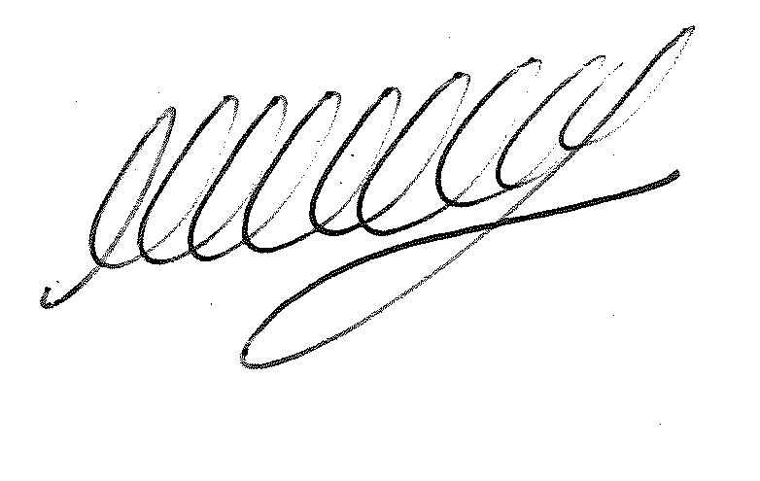**SIGNED…………………………………………………… DATE 9th September 2024**

**M WELLS**

**TOWN CLERK**

***\*Copies of any correspondence circulated to Councillors with this agenda, which will be considered at this meeting.***

**Reminder for Members:**

* **You must declare the nature of any disclosable pecuniary interests (under the Localism Act 2011, this means the interests of your spouse, or civil partner, a person with whom you are living with as husband and wife or a person with whom you are living as if you are civil partners). You must also disclose any personal interest.**
* **You must disclose your interest in an item whenever it becomes apparent that you have an interest in the business being considered.**
* **Make sure you say what your interest is, as this has to be included in the minutes. (For example, ‘I have a disclosable pecuniary interest because this planning application is made by my husband’s employer’).**
* **If your interest is a disclosable pecuniary interest, you cannot participate in the discussion, cannot vote and must leave the room unless you have obtained a dispensation from the Clerk.**