

27th August 2024

**To: Members of the Finance, Resources & General Purposes Committee**

Cllrs Brooke (Ex Officio), Allen, Burton, Evans, Fletcher, Kennedy & Oldrieve.

Cc: All other Members of the Council for information**.**

Dear Councillor,

You are hereby summoned to attend a meeting of the **Finance, Resources and General Purposes (FR&GP) Committee** on **Monday 2nd September 2024** at **7.00 pm** at the **Riverside Community Centre** for the purpose of transacting the business as set out on the agenda below.

**AGENDA**

**FR&GP.24/48 Apologies for absence**

To **receive** and **consider** for acceptance, apologies for inability to attend.

**FR&GP.24/49 Declarations of Interest and Requests for Dispensations**

To **declare** any disclosable pecuniary interests or any other interest which members may have in the following agenda items and **consider** any dispensation requests.

**\*\*Public Participation:**

*We welcome the public to attend meetings and invite comments or questions regarding any of the agenda items. The Committee, at the Chairman’s discretion, sets aside a short period of time for this at the commencement of the meeting.*

**FR&GP.24/50 Minutes**:

i) To **agree** as a correct record and **approve** the minutes of the meeting of 10th June 2024 *(*[*\*copy enclosed*](https://www.dropbox.com/scl/fi/wcausyrn1urbskh2ktpvr/02.09.24-Draft-Minutes-of-FR-GP-Committee-Meeting-of-10.06.24-v2.docx?rlkey=oj6a6r205lt69c4sye83hag8v&dl=0)*).*

ii) To **receive** any update(s) on actions/items from the previous meeting.

**FR&GP.24/51 Standing Item – Climate and Ecology Emergencies:**

To **note** the Council Declaration and to embed the climate and ecology emergency declaration across all Council services, activities, plans and other relevant work, considering the environmental impact of decisions, ensuring a fully integrated approach to mitigating the impact of climate change.

**FR&GP.24/52 Accounts & Financial Statement(s)**:

i) **Receive** and **approve** payment and receipt transactions between 1st June 2024 and 20th August 2024 *(*[*\*copy enclosed*](https://www.dropbox.com/scl/fi/1sgn4zbj5rud69azukl38/02.09.24-Payment-and-Receipt-Transactions-1st-June-20th-August-2024.pdf?rlkey=fkhc6lnnpsw1hff2xkab7zthe&dl=0)*).*

ii) **Receive** and **approve** bank reconciliation between 1st June 2024 and 20th August 2024 *(*[*\*copy enclosed*](https://www.dropbox.com/scl/fi/imig5pd1shq04y51dxqp6/02.09.24-Bank-Cash-and-Investment-Reconciliation-as-at-20-August-2024.pdf?rlkey=6lsixkli1sdrto5akj6m3b77j&dl=0)*).*

iii) **Receive** and **note** the balances and borrowing as below:

General Account: £ 4,835.18 (as at 20.08.24)

Income/Precept A/C: £ 104,708.13 (as at 20.08.24)

Capital A/C: £ 45,370.13 (as at 20.08.24)

CIL A/C: £ 187,479.42 (as at 20.08.24)

National Lottery Grant: £ 35,591.32 (as at 20.08.24)

Redwood Bank (Rev) £ 85,000.00 (as at 20.08.24)

Charity Bank Invest (Rev) £ 85,000.00 (as at 20.08.24)

Cambridge & Counties (CiL) £ 85,000.00 (as at 20.08.24)

Nationwide Build Soc (CiL) £ 85,000.00 (as at 20.08.24)

B’hamshire Build Soc (Cap) £ 110,000.00 (as at 20.08.24)

Borrowing

Public Sector Works Loan £ 377,854.31 (as at 20.08.24)

**FR&GP.24/53 Annual Return for the Year Ending 31st March 2024:**

To **receive** and **note** the outcome of the 2023/24 External Audit undertaken by PKF Littlejohn LLP ([*\*copy enclosed*](https://www.dropbox.com/scl/fi/nw20g6jgvyfh7msraxf8y/02.09.24-PKF-Littlejohn-External-Audit-Report-for-2023-24.pdf?rlkey=jqnm2ykz1e8easswwhl90bukg&dl=0)).

**FR&GP.24/54 2024/25 Budget Monitoring – Quarter 1:**

To **receive** and **note** the Town Council’s Quarter 1 budget monitoring statement ([*\*copy enclosed*](https://www.dropbox.com/scl/fi/bkwe2wan00mkth9uxj6iw/02.09.24-Annual-Budget-By-Centre-Actual-YTD-Month-4-Quarter-1.pdf?rlkey=274vw8c91elkqo4nmxa8ztymd&dl=0)).

**FR&GP.24/55 2024/25 Budget Setting Process:**

To **consider** and **approve** the process for budget/precept setting for the ensuing year ([*\*copy enclosed*](https://www.dropbox.com/scl/fi/5apd0gsiorssfywfgu536/02.09.24-Setting-the-Precept-Process-for-2025-26.pdf?rlkey=0640uiqmdtdvoiwgsa5ylw3yw&dl=0)).

**FR&GP.24/56 CiL Community Groups Policy (Deferred Item – FR&GP.24/39):**

To **receive** the amended CiL Community Groups Policy (following review by the Task & Finish Group) and **consider** a recommendation to Full Council to re-adopt or any other action as appropriate ([*\*copy enclosed*](https://www.dropbox.com/scl/fi/383w9hw9pv2gwvqk2akgw/02.09.24-CIL-Community-Groups-Policy-Revised-July-2024.pdf?rlkey=m0fvivday620317sax2b8m508&dl=0)).

**FR&GP.24/57 Direct Debits and Standing Orders (Deferred Item - FR&GP.24/41):**

To **receive** and **consider** approving a list of Direct Debit/Standing Order Payments *(*[*\*copy enclosed*](https://www.dropbox.com/scl/fi/3piiuosaztqpem1aywh9c/02.09.24-Copy-of-Revised_Payments_Database_DDContracts_2024.pdf?rlkey=4todj2otf0o5s9htazgi0gy4y&dl=0)*).*

**FR&GP.24/58 Financial Regulations (Deferred Item – FR&GP.24/43):**

To **receive** the amended Financial Regulations and **consider** a recommendation to Full Council to **adopt** **or agree** any other action as appropriate ([*\*copy enclosed*](https://www.dropbox.com/scl/fi/um6hn4mvimf05ydvmi9g1/02.09.24-Financial-Regulations-Report.pdf?rlkey=q184q0boq753j66pppy26q185&dl=0)).

**FR&GP.24/59 Electronic Devices (Deferred Item – FR&GP.24/45):**

To **receive** a policy and **consider** a recommendation to Full Council to adopt ([*\*copy enclosed*](https://www.dropbox.com/scl/fi/7zkdl0ajem2y4rfotnayw/02.09.24-IT-for-Councillors-Policy-July-2024.pdf?rlkey=aqdew6c2btlmctbz3mbwrqm4l&dl=0)).

**FR&GP.24/60 Bike Lockers – Station Road Car Park**

To **receive** and **consider** a report to agree fees and charges ([*\*copy enclosed*](https://www.dropbox.com/scl/fi/4wjhmx3ejl74as5bklqdl/02.09.24-Bike-Locker-Report.pdf?rlkey=a0u9dmdqz62534a2xl2sfbkm1&dl=0)).

**FR&GP.24/61 Grant Requests – Review (Teignbridge Citizens Advice - Heathfield)**

To undertake a **6-month** **review** of the grant award made in March 2024 and to **agree** whether or not to terminate the current arrangement.

**FR&GP.24/62 Matters brought forward by Councillors/Clerk:** *(for information only*).

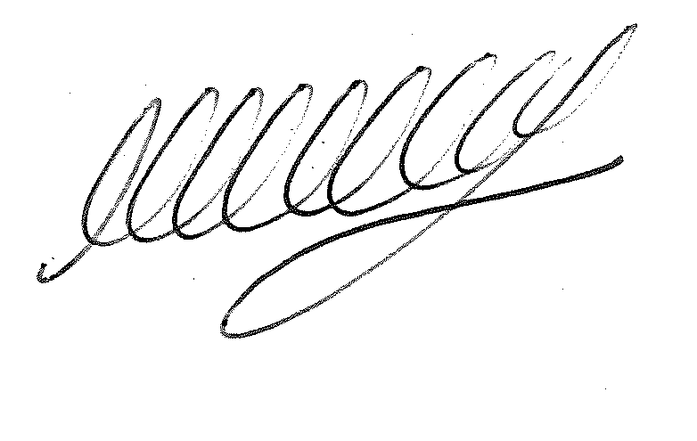

**SIGNED DATE: 27th August 2024**

**M WELLS - TOWN CLERK**

***\*Copies of correspondence circulated to Councillors with this agenda, which will be considered at the meeting.***