

22nd October 2024

**To: Members of the Finance, Resources & General Purposes Committee**

Cllrs Brooke (Ex Officio), Allen, Burton, Evans, Fletcher, Kennedy & Oldrieve.

Cc: All other Members of the Council for information**.**

Dear Councillor,

You are hereby summoned to attend a meeting of the **Finance, Resources and General Purposes (FR&GP) Committee** on **Monday 28th October 2024 at 7.00 pm** at the **Riverside Community Centre** for the purpose of transacting the business as set out on the agenda below.

**AGENDA**

**FR&GP.24/63 Apologies for absence**

To **receive** and **consider** for acceptance, apologies for inability to attend.

**FR&GP.24/64 Declarations of Interest and Requests for Dispensations**

To **declare** any disclosable pecuniary interests or any other interest which members may have in the following agenda items and **consider** any dispensation requests.

**\*\*Public Participation:**

*We welcome the public to attend meetings and invite comments or questions regarding any of the agenda items. The Committee, at the Chairperson’s discretion, sets aside a short period of time for this at the commencement of the meeting.*

**FR&GP.24/65 Minutes**:

i) To **agree** as a correct record and approve the minutes of the meeting of 2nd September 2024 *(*[*\*copy enclosed*](https://www.dropbox.com/scl/fi/s4fmg9ci4fb2n5mxf7wlu/28.10.24-Draft-Minutes-of-FR-GP-Committee-Meeting-of-02.09.24.docx?rlkey=hu3imqhe5hvwlphvmg46sjurc&dl=0)*).*

ii) To **receive** any update(s) on actions/items from the previous meeting.

**FR&GP.24/66 Standing Item – Climate and Ecology Emergency:**

To **note** the Council Declaration and to embed the climate and ecology emergency declaration across all Council services, activities, plans and other relevant work, considering the environmental impact of decisions, ensuring a fully integrated approach to mitigating the impact of climate change.

**FR&GP.24/67 Accounts & Financial Statement**:

To **receive** and **approve:**

i) Payment and receipt transactions between 21st August 2024 and 17th October 2024 *(*[*\*copy enclosed*](https://www.dropbox.com/scl/fi/fm63p9k5nk7ye4r3ekmsh/28.10.24-Payment-and-Receipt-Transactions-21.08.24-17.10.24.pdf?rlkey=wvm7xa8s9xcn0pubheq5lixyf&dl=0)*)*

ii) bank reconciliation between 21st August 2024 and 17th October 2024 *(*[*\*copy enclosed*](https://www.dropbox.com/scl/fi/tcrwtgn675fdyc6xkqc4o/28.10.24-Cash-and-Investment-Reconciliation-as-at-17-October-2024.pdf?rlkey=8559f1947dhu0tr8vv0ztd21x&dl=0)*)*

iii) **note** the balances and borrowing as below:

General Account: £ 12,869.99 (as at 17.10.24)

Income/Precept A/C: £ 206,039.55 (as at 17.10.24)

Capital A/C: £ 45,445.98 (as at 17.10.24)

CIL A/C: £ 137,724.36 (as at 17.10.24)

National Lottery Grant: £ 35,649.49 (as at 17.10.24)

Redwood Bank (Rev) £ 85,000.00 (as at 17.10.24)

Charity Bank Invest (Rev) £ 85,000.00 (as at 17.10.24)

Cambridge & Counties (CiL) £ 85,000.00 (as at 17.10.24)

Nationwide Build Soc (CiL) £ 85,000.00 (as at 17.10.24)

B’hamshire Build Soc (Cap) £ 110,000.00 (as at 17.10.24)

Borrowing

Public Sector Works Loan £ - 382,206.92 (as at 03.10.24)

**FR&GP.24/68 Gift of residue of Estate**

To **receive** solicitor correspondence ([*\*copy enclosed*](https://www.dropbox.com/scl/fi/dwd2ksiexxphpvsoh4pqn/28.10.24-Estate-of-Michael-O-Brien-Insall.pdf?rlkey=sqhlt7uzvhs1gqok42ojqjqgc&dl=0)) in relation to the gift of residue of an Estate and to **consider** agreeing action(s) as recommended within.

**FR&GP.24/69 Document Retention Policy**

To **review** and **consider** re-adopting:

1. Document Retention Policy ([*\*copy enclosed*](https://www.dropbox.com/scl/fi/vbe1ta2boitoswo8iw4ex/28.10.24-SLCC-Model-Document-Retention-Policy.pdf?rlkey=ut4xzf590ep3gjpalwpzxk1zv&dl=0))
2. List of documents for retention/disposal ([*\*copy enclosed*](https://www.dropbox.com/scl/fi/g52ul5h4c1eqkhn76kp5q/28.10.24-Updated-Retention-of-Documents-Appendix-A-List.pdf?rlkey=0ovcf5bfcaxoh3eqkpjyx5hxq&dl=0))

**FR&GP.24/70 Budget Monitoring – Position Statement:**

To **receive** and **note** the Town Council’s half yearly budget monitoring statement as at 1st October 2024, or any other action as appropriate *(*[*\*copy enclosed*](https://www.dropbox.com/scl/fi/jku6fo405gtbq20c4evz8/28.10.24-Council-Detail-Report-Half-Year-Oct-2024.pdf?rlkey=eldr58utbyouyfdklylofr7wn&dl=0)*).*

**FR&GP.24/71 Interim Audit**

To **receive** and **consider** the recommendations and subsequent actions highlighted within the audit report *(*copy to be circulated).*

**FR&GP.24/72 Maturity of Investments**

To **receive** a report and **consider** the recommendations within ([*\*copy enclosed*](https://www.dropbox.com/scl/fi/6gycslr3pch29zokuywnq/15.10.24-Council-Re-investments.pdf?rlkey=qxessm47c4dk3yioomru0ft06&dl=0)).

**FR&GP.24/73 Electronic Devices Policy (Deferred item FR&GP.24/59)**

To **consider** making a recommendation to Full Council to adopt the revised Policy ([*\*copy enclosed*](https://www.dropbox.com/scl/fi/d2l5e0etuzfksl1f3o72t/28.10.24-IT-for-Councillors-Policy-October-2024.pdf?rlkey=f6qwufl52g1w2dwmyx91g6pov&dl=0)).

**FR&GP.24/74 Additional Solar PV Battery Storage – Riverside Community Centre**

To **receive** a report and **consider** the recommendations within ([*\*copy enclosed*](https://www.dropbox.com/scl/fi/3gn8fw8u2derme53gsae2/28.10.24-Additional-Battery-Storage-Riverside-CC.pdf?rlkey=1fhvyte0u21ixawyoww1bbpxl&dl=0)).

**FR&GP.24/75** **Utilities (Gas/Electricity) (Deferred item FR&GP.24/61):**

To **receive** a report and **consider** the recommendations within ([*\*copy enclosed*](https://www.dropbox.com/scl/fi/xde1ngx0dx1blmao2dc06/28.10.24-Utility-Provider-Switch-Request.pdf?rlkey=yq9d9oy391seukw0jcqx5csbb&dl=0)).

**FR&GP.24/76 Matters brought forward by Councillors:** *(for information only*).

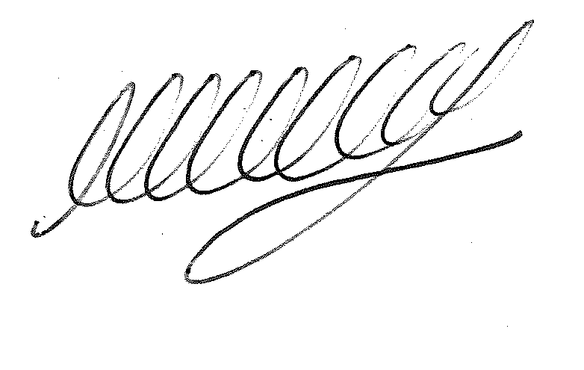

**SIGNED DATE: 22nd October 2024**

**M WELLS - TOWN CLERK**

***\*Copies of correspondence circulated to Councillors with this agenda, which will be considered at the meeting.***