

8th April 2025

**To: Members of the Finance, Resources & General Purposes Committee**

Cllrs Brooke (Ex Officio), Allen, Burton, Evans, Fletcher, Kennedy & Oldrieve.

Cc: All other Members of the Council for information**.**

Dear Councillor,

You are hereby summoned to attend a meeting of the **Finance, Resources and General Purposes (FR&GP) Committee** on **Monday 14th April 2025 at 7.00 pm** at the **Riverside Community Centre** for the purpose of transacting the business as set out on the agenda below.

**AGENDA**

**FR&GP.25/29 Apologies for absence**

To **receive** and **consider** for acceptance, apologies for inability to attend.

**FR&GP.25/30 Declarations of Interest and Requests for Dispensations**

To **declare** any disclosable pecuniary interests or any other interest which members may have in the following agenda items and **consider** any dispensation requests.

**\*\*Public Participation:**

*We welcome the public to attend meetings and invite comments or questions regarding any of the agenda items. The Committee, at the Chairperson’s discretion, sets aside a short period of time for this at the commencement of the meeting.*

**FR&GP.25/31 Minutes**:

i) To **agree** as a correct record and **approve** the minutes of the meeting of 3rd March 2025 *(*[*\*copy enclosed*](https://www.dropbox.com/scl/fi/bv24sx9uar12ouz9fgwvr/14.04.25-Draft-Minutes-of-FR-GP-Committee-Meeting-of-03.03.25-v3.docx?rlkey=dgl0ddtkb6cj5854wpfyyd8rl&dl=0)*).*

ii) To **receive** any update(s) on actions/items from the previous meeting.

**FR&GP.25/32 Standing Item – Climate and Ecology Emergencies:**

To **note** the Council Declaration and to embed the climate and ecology emergency declaration across all Council services, activities, plans and other relevant work, considering the environmental impact of decisions, ensuring a fully integrated approach to mitigating the impact of climate change.

**FR&GP.25/33 Accounts & Financial Statement**:

To **receive** and **approve:**

i) Payment and receipt transactions between 24th February 2025 and 31st March 2025 *(*[*\*copy enclosed*](https://www.dropbox.com/scl/fi/2a5mgd6et9msbsfq636qg/14.04.25-Payment-and-Receipt-Transactions-24.02.25-31.03.25.pdf?rlkey=u8zrjaj9b48jeluegbalnt4a4&dl=0)*).*

ii) Bank reconciliation between 24th February 2025 and 31st March 2025 *(*[*\*copy enclosed*](https://www.dropbox.com/scl/fi/79zo19y9ma6pi4w4pt760/14.04.25-Bank-Cash-and-Investment-Reconciliation-as-at-1-April-2025.pdf?rlkey=txqrz4wgp8oexrhz2buxgiovj&dl=0)*).*

iii) **note** the balances and borrowing as below:

General Account: £ 9,418.23 (as at 31.03.25)

Income/Precept A/C: £ 91,206.11 (as at 31.03.25)

Capital A/C: £ 47,804.30 (as at 31.03.25)

CIL A/C: £ 60,730.66 (as at 31.03.25)

National Lottery Grant: £ 36,388.27 (as at 31.03.25)

Redwood Bank (Rev) £ 85,000.00 (as at 31.03.25)

Charity Bank Invest (Rev) £ 85,000.00 (as at 31.03.25)

Cambridge & Counties (CiL) £ 130,000.00 (as at 31.03.25)

Nationwide Build Soc (CiL) £ 130,000.00 (as at 31.03.25)

B’hamshire Build Soc (Cap) £ 110,000.00 (as at 31.03.25)

Hampshire Trust Bank (CiL) £ 130,000.00 (as at 31.03.25)

Borrowing

Public Sector Works Loan £ - 386,748.04 (as at 31.03.25)

**FR&GP.25/34 Policy Reviews:**

To **review** and **consider** a recommendation to Full Council to re-adopt the following policies:

- Data Protection Policy ([*\*copy enclosed*](https://www.dropbox.com/scl/fi/0znkrqziz9yqmy25624ct/14.04.25-SLCC-Model-Information-Data-Protection-Policy.docx?rlkey=6oefaqwon2n4efkt7d8n42cl8&dl=0))

- Data Breach Policy ([*\*copy enclosed*](https://www.dropbox.com/scl/fi/pton36lcluccoiru2msoo/14.04.25-Data-Breach-Policy.docx?rlkey=44bwqnk7xo448dpixsyrvozkr&dl=0))

- Subject Access Request ([*\*copy enclosed*](https://www.dropbox.com/scl/fi/sbccj3vh8kic3qzeydn0n/14.04.25-Subject-Access-Requests-Policy.docx?rlkey=57pccte6nq1crfa0y90zlsbxf&dl=0))

**FR&GP.25/35 Deferred Item FR&GP.25/21 Grant Request(s):**

To **receive** and **consider** a deferred application for grant funding from:

1. £1,500 - Moorland Community Care Group ([*\*copy enclosed*](https://www.dropbox.com/scl/fi/tgvhbnpd2x257k69drk5j/14.04.25-Grant-Application-Bovey-Town-Council-MCC-April-2025.pdf?rlkey=cq8rumbu3qc2hd6eb0wj85els&dl=0))

**FR&GP.25/36 CiL Groups Policy – Grant Application:**

To **receive** and **consider** approving a grant application on behalf of Bovey Tracey Swimming Pool Trust ([*\*copy enclosed*](https://www.dropbox.com/scl/fi/pn1tuxd4vqy6ae51jlbpn/14.04.25-CiL-Grant-Application-Bovey-Tracey-Swimming-Pool.pdf?rlkey=n4ig1dyyj1mw9r6zk5e58qrkx&dl=0)).

**FR&GP.25/37 Request for Use of Revenue Reserves:**

To **receive** and **consider** approving a request from the Personnel Committee (if received), for use of existing revenue reserves.

**FR&GP.25/38 Year End Budget Position – 31st March 2024:**

To **receive** and **note** the budget position as at the end of the financial year for 2024/25 ([*\*copy enclosed*](https://www.dropbox.com/scl/fi/9cwsz82q2761pgoe76mlf/14.04.25-Annual-Budget-By-Centre-Actual-YTD-Month-12.pdf?rlkey=wl934ep2ky3xz8l6n2jhzi80v&dl=0)).

**FR&GP.25/39 Matters brought forward by Councillors:** *(for information only*).

**SIGNED DATE: 8th April 2025**

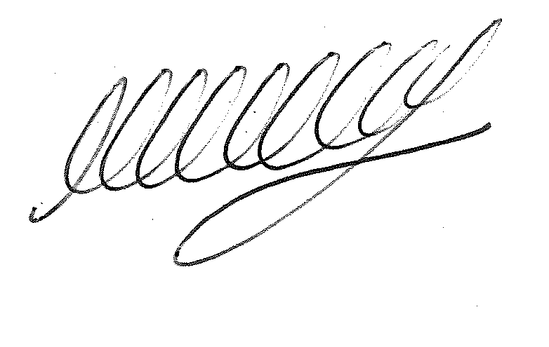

**M WELLS - TOWN CLERK**

***\*Copies of correspondence circulated to Councillors with this agenda, which will be considered at the meeting.***