

30th December 2024

**To: Members of the Finance, Resources & General Purposes Committee**

Cllrs Brooke (Ex Officio), Allen, Burton, Evans, Fletcher, Kennedy & Oldrieve.

Cc: All other Members of the Council for information**.**

Dear Councillor,

You are hereby summoned to attend a meeting of the **Finance, Resources and General Purposes (FR&GP) Committee** on **Monday 6th January 2025 at 7.00 pm** at the **Riverside Community Centre** for the purpose of transacting the business as set out on the agenda below.

**AGENDA**

**FR&GP.25/01 Apologies for absence**

To **receive** and **consider** for acceptance, apologies for inability to attend.

**FR&GP.25/02 Declarations of Interest and Requests for Dispensations**

To **declare** any disclosable pecuniary interests or any other interest which members may have in the following agenda items and **consider** any dispensation requests.

**\*\*Public Participation:**

*We welcome the public to attend meetings and invite comments or questions regarding any of the agenda items. The Committee, at the Chairperson’s discretion, sets aside a short period of time for this at the commencement of the meeting.*

**FR&GP.25/03 Minutes**:

i) To **agree** as a correct record and approve the minutes of the meeting of 28th October 2024 *(*[*\*copy enclosed*](https://www.dropbox.com/scl/fi/k3wd504f4l2kutsts3dvu/06.01.25-Draft-Minutes-of-FR-GP-Committee-Meeting-of-28.10.24.docx?rlkey=ewdv6g2zy7xnqfr22acer2gu8&dl=0)*).*

ii) To **receive** any update(s) on actions/items from the previous meeting.

**FR&GP.25/04 Standing Item – Climate and Ecology Emergencies:**

To **note** the Council Declaration and to embed the climate and ecology emergency declaration across all Council services, activities, plans and other relevant work, considering the environmental impact of decisions, ensuring a fully integrated approach to mitigating the impact of climate change.

**FR&GP.25/05 Accounts & Financial Statement**:

To **receive** and **approve:**

i) Payment and receipt transactions between 18th October 2024 and 22nd December 2024 *(*[*\*copy enclosed*](https://www.dropbox.com/scl/fi/d358ovyyd6zubaawutq5d/06.01.25-Payments-and-Receipt-Transactions-18.10.24-22.12.24.pdf?rlkey=26hig11dk4d3d4ticlm37t8it&dl=0)*).*

ii) Bank reconciliation between 18th October 2024 and 22nd December 2024 *(*[*\*copy enclosed*](https://www.dropbox.com/scl/fi/ijhbl568hgols00fgh0wh/06.01.25-Cash-and-Investment-Reconciliation-as-at-22nd-December-2024.pdf?rlkey=3pxkkqry4kgy9g1hivvz4p2wq&dl=0)*).*

iii) **note** the balances and borrowing as below:

General Account: £ 17,505.84 (as at 22.12.24)

Income/Precept A/C: £ 156,394.68 (as at 22.12.24)

Capital A/C: £ 45,521.96 (as at 22.12.24)

CIL A/C: £ 116,058.40 (as at 22.12.24)

National Lottery Grant: £ 22,910.51 (as at 22.12.24)

Redwood Bank (Rev) £ 85,000.00 (as at 22.12.24)

Charity Bank Invest (Rev) £ 85,000.00 (as at 22.12.24)

Cambridge & Counties (CiL) £ 130,000.00 (as at 22.12.24)

Nationwide Build Soc (CiL) £ 85,000.00 (as at 22.12.24)

B’hamshire Build Soc (Cap) £ 110,000.00 (as at 22.12.24)

Hampshire Trust Bank (CiL) £ 130,000.00 (as at 22.12.24)

Borrowing

Public Sector Works Loan £ - 382,206.92 (as at 2212.24)

**FR&GP.25/06 Budget Monitoring – Position Statement:**

To **receive** and **note** the Town Council’s budget monitoring statement as at 22nd December 2024 ([*\*copy enclosed*](https://www.dropbox.com/scl/fi/y6ccw6ay4yi8etpqgf6pz/06.01.25-Budget-Statement-December-2024.pdf?rlkey=tnc10crsiojjiqkvqnffhy61a&dl=0)).

**FR&GP.25/07 Budget and Precept 2025/26:**

To **discuss** and **agree** a recommendation to Full Council for the setting of the 2025/26 precept following consideration of:

1. A review of the current level of reserves ([*\*copy enclosed*](https://www.dropbox.com/scl/fi/2juf3jimuixnf25setoze/06.01.25-General-and-Earmarked-Reserves-2024-2025.pdf?rlkey=7o8t55eiw6v6d4gufxmba4a3k&dl=0))
2. Draft budget ([*\*copy enclosed*](https://www.dropbox.com/scl/fi/lxz1w0r0p5veo56ww1op0/06.01.25-Budget-2025-26-to-2027-28-v3.pdf?rlkey=sv6lpqeo6ra8uwvl0ohgnie2o&dl=0))

**FR&GP.25/08 Utilities (Gas/Electricity) (Deferred item FR&GP.24/75 & FR&GP.24/61):**

To **receive** an updated report and to **consider** the actions/recommendations within ([*\*copy enclosed*](https://www.dropbox.com/scl/fi/6mnpbvskxqdq5lihp7skp/06.01.25-Utility-Provider-Switch-Request.pdf?rlkey=sjwdzgai0qk0eyjpaslwrk8c9&dl=0)).

**FR&GP.25/09 Risk Management:**

1. To **review** and **recommend to Full Council the re-adoption** of Financial and non-Financial Internal Controls ([*\*copy enclosed*](https://www.dropbox.com/scl/fi/pb6c6e7sjgl49y55z0rst/06.01.25-Internal-Controls-Colour-coded-January-2025.doc?rlkey=zpmrkkkr33kh3tegdiuchytgq&dl=0))
2. To **recommend to Full Council** the adoption of a Risk Register ([*\*copy enclosed*](https://www.dropbox.com/scl/fi/ppd2wg6eu79vjqmxzq9t1/06.01.25-Risk-Management-Register-2024.docx?rlkey=ywar6uydrtx9387hv3wjvf3qd&dl=0)).

**FR&GP.25/10 Model Publication Scheme:**

To **receive** a draft revised Scheme and **consider** a **recommendation to Full Council** to adopt the scheme ([*\*copy enclosed*](https://www.dropbox.com/scl/fi/sso53zg28wrkwoz9vbpow/06.01.25-Model-Publication-Scheme-November-2024.doc?rlkey=5pyezl3ezljci5mctjcp8evd5&dl=0)).

**FR&GP.25/11 Noticeboard(s) – Mill Marsh Park and Heathfield:**

i) To **consider** approving installation of a new noticeboard in Mill Marsh Park with the refurbishment of the existing noticeboard and installation in Heathfield.

ii) If approved, to **agree** **a quotation** (to be provided at the meeting) and agree relevant funding source.

**FR&GP.25/12 Mill Marsh Park - Outdoor Exercise Equipment Refurbishment:**

To **receive** and **consider** a recommendation from the Recreation, Parks & Property Committee to **allocate** and **approve** a budget of £60,000.00 towards the redevelopment of the outdoor exercise equipment in Mill Marsh Park.

**FR&GP.25/13 Matters brought forward by Councillors:** *(for information only*).

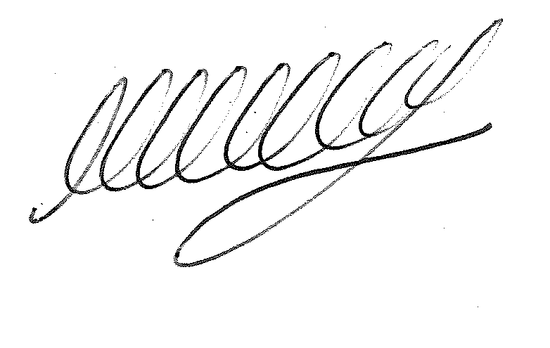

**SIGNED DATE: 30th December 2024**

**M WELLS - TOWN CLERK**

***\*Copies of correspondence circulated to Councillors with this agenda, which will be considered at the meeting.***