7th November 2022

Under ‘The Openness of Local Government Bodies Regulations 2014’ this meeting has been advertised as a public meeting and as such could be filmed or recorded by broadcasters, the media or members of the public.

* The Town Council invites members of the public to ask questions or raise issues relevant to the work of the Council. The overall time available for this session is restricted to 15 minutes unless the Chair decides otherwise. Please note: questions to be submitted in writing, to arrive via email at the Council Office by 12 noon on the day of this meeting.

Dear Councillor,

You are hereby summoned to attend a meeting of Bovey Tracey Town Council on Monday 14th November 2022 at 7.00pm at St Catherine’s School (Heathfield) for the purpose of transacting the business as set out on the agenda below.

AGENDA

FC.22/61 Apologies for absence
To receive and consider for acceptance apologies for inability to attend.

FC.22/62 Declarations of Interest and Requests for Dispensations
To declare any disclosable pecuniary interests or any other interest which members may have in the following agenda items and consider any dispensation requests.

FC.22/63 Minutes
i) To receive and resolve as a correct record the minutes of the Full Council meeting held on 26.09.22 (*copy enclosed).
ii) To receive an update on any matters arising from the previous Full Council meeting (if any).

FC.22/64 Standing Item – Climate Emergency:
To note the Council Declaration and to embed the Climate Emergency Declaration across all Council services, activities, plans and other relevant work, considering the environmental impact of decisions, ensuring a fully integrated approach to mitigating the impact of climate change.

The meeting will go out of session

FC.22/65 Reports from Key Bodies on Parish related matters:
To receive the reports (if any) from key bodies including:
i) Chaplain to the Council
ii) Police (*copy enclosed)
iii) County (Cllr Gribble) (*copy enclosed), District (Cllr Kerswell & Cllr Morgan) and Town Councillors (all)
iv) Town Mayors Interests (*copy enclosed)
v) Other outside bodies

FC.22/66 Questions and Statements by the Public
The Town Mayor will invite Members of the Public to give their views and question the Town Council on issues on this agenda, or raise issues for future consideration (maximum 3 minutes per person).

The meeting will go back into session

FC.22/67 Business Raised by the Public:
To resolve to refer any business raised by the public in public discussion and any other matters or items of information from Councillors, to the appropriate Committee or to resolve to agree on any other action.

FC.22/68 Recreation, Parks & Property Committee (RP&P) Committee:
i) To receive and adopt the minutes of the meeting held on 17.10.22 (*draft copy enclosed).
ii) To receive a deferred item around the installation of an external flagpole at the Riverside Community Centre and consider any further action as appropriate (RP&P.22/52).

FC.22/69 Finance, Resources & General Purposes (FR&GP) Committee:
To receive and adopt the minutes of the meeting held on 31.10.22 (*draft copy enclosed).

FC.22/70 Planning & Environment Committee:
i) To receive and adopt the minutes of the meetings held on 03.10.22, (*copy enclosed), 17.10.22 (*copy enclosed) & 31.10.22 (*draft copy enclosed).

FC.22/71 Community Awards 2023
To receive and consider a report from Cllr Allen (*copy enclosed)

FC.22/72 Climate and Ecology Bill
To receive and consider a report from Cllr Fletcher (*copy enclosed)

FC.22/73 Tidy Teignbridge Local Area Clean Up Fund – 2023/24
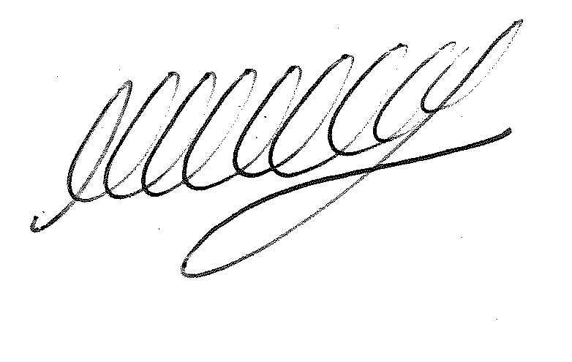To receive guidance for the fund and consider any further action as appropriate (*copy enclosed).

SIGNED…………………………………………………… DATE 7th November 2022

M WELLS
TOWN CLERK

*Copies of any correspondence circulated to Councillors with this agenda, which will be considered at this meeting.

Reminder for Members:

- You must declare the nature of any disclosable pecuniary interests (under the Localism Act 2011, this means the interests of your spouse, or civil partner, a person with whom you are living with as husband and wife or a person with whom you are living as if you are civil partners). You must also disclose any personal interest.

- You must disclose your interest in an item whenever it becomes apparent that you have an interest in the business being considered.

- Make sure you say what your interest is, as this has to be included in the minutes. (For example, ‘I have a disclosable pecuniary interest because this planning application is made by my husband’s employer’).

- If your interest is a disclosable pecuniary interest, you cannot participate in the discussion, cannot vote and must leave the room unless you have obtained a dispensation from the Clerk.

