Bovey Tracey Annual Town Meeting

Wednesday 26th March 2025

Riverside Community Centre

Station Road

Bovey Tracey

TQ13 9AW

All residents of Bovey Tracey Parish are warmly invited to the Annual Town Meeting at the Riverside Community Centre. **Coffee and cake will be available from 6.00pm, come early and enjoy some refreshments.**

The evening kicks off at **6.45pm** with a short presentation about Bovey Tracey’s role as a Fairtrade Town and the meeting officially starts at **7.00pm.**

*Why not drop by to learn more about what’s happening locally? There will be displays by various Community Groups beforehand, giving you the chance to chat with them and find out how you can get involved.*

## ***6.45pm Bovey Parish – A Fairtrade Town***

## **Meeting Agenda** (Starting at 7.00pm)

#### **1.** **Welcome and Introductions**

#### The Town Mayor of Bovey Tracey, Sheila will get things started with a warm welcome.

### **2.** **Minutes of the Annual Town Meeting**

i) Approval of the minutes from last year’s meeting held on 27th March 2024 ([*\*copy enclosed*](https://www.dropbox.com/scl/fi/sukvrqvf8kzonx1j24lxv/26.03.25-ATM-Mins-27.03.24-DRAFT.docx?rlkey=6fd5wabzrigrgosakvyi386z3&dl=0)).

ii) The Town Mayor will provide a recap of what the Town Council has been up to over the past year.

**3. Community Awards**

Let’s celebrate! The 2025 Community Awards will be presented.

**4. Community Reports**

Community reports from Clubs, Societies, Charities, Schools, Churches, other Groups and Organisations in Bovey Tracey and Heathfield, about what they have been working on, will be available*.*

**5. Public Question Time**

Got something on your mind? This is your chance to ask questions or share your thoughts.

We hope to see you there!

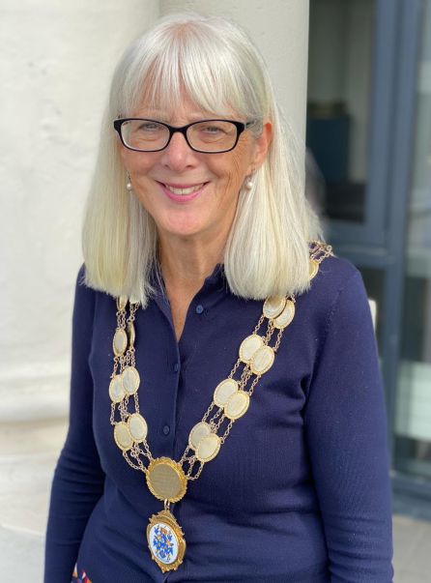

Cllr Sheila Brooke –Town Mayor