29th August 2023

To Members of the Finance, Resources & General Purposes Committee

Cllrs Brooke (Ex Officio), Allen, Burton, Evans, Fletcher, Kennedy & Oldrieve.

Cc: All other Members of the Council for information.

Dear Councillor,

You are hereby summoned to attend a meeting of the Finance, Resources and General Purposes (FR&GP) Committee on Monday 4th September 2023 at 7.00 pm at the Riverside Community Centre for the purpose of transacting the business as set out on the agenda below.

AGENDA

FR&GP.23/51 Apologies for absence
To receive and consider for acceptance, apologies for inability to attend.

FR&GP.23/52 Declarations of Interest and Requests for Dispensations
To declare any disclosable pecuniary interests or any other interest which members may have in the following agenda items and consider any dispensation requests.

**Public Participation:
We welcome the public to attend meetings and invite comments or questions regarding any of the agenda items. The Committee, at the Chairman’s discretion, sets aside a short period of time for this at the commencement of the meeting.

FR&GP.23/53 Minutes:
i) To agree as a correct record and approve the minutes of the meeting of 12th June 2023 (*copy enclosed).
ii) To receive any update(s) on actions/items from the previous meeting.

FR&GP.23/54 Standing Item – Climate and Ecology Emergency:
To note the Council Declaration and to embed the climate and ecology emergency declaration across all Council services, activities, plans and other relevant work, considering the environmental impact of decisions, ensuring a fully integrated approach to mitigating the impact of climate change.

FR&GP.23/55 Accounts & Financial Statement:
To receive and approve:
i) Payment and receipt transactions between 1st June 2023 and 23rd August 2023 (*copy enclosed)
ii) bank reconciliation between 1st June 2023 and 23rd August 2023 (*copy enclosed)

iii) note the balances and borrowing as below:
General Account: £ 9,967.75 (as at 23.08.23)
Income/Precept A/C: £ 179,686.99 (as at 23.08.23)
Capital A/C: £ 45,318.50 (as at 23.08.23)
CIL A/C: £ 163,805.87 (as at 23.08.23)
National Lottery Grant: £ 35,573.48 (as at 23.08.23)
Charity Bank Invest (Rev) £ 85,746.41 (as at 23.08.23)
Cambridge & Counties (CiL) £ 85,000.00 (as at 23.08.23)
Nationwide Build Soc (CiL) £ 85,000.00 (as at 23.08.23)
B’hamshire Build Soc (Cap) £ 110,000.00 (as at 23.08.23)

Borrowing
Public Sector Works Loan £ - 427,586.16 (as at 31. 03.23)

FR&GP.23/56 Policies (Deferred Item FR&GP.23/42)
i) To review and consider a recommendation to re-adopt the Treasury & Investment Policy (*copy enclosed)
ii) To receive and consider a recommendation to Full Council to adopt a CiL Groups Policy (*copy enclosed)

FR&GP.23/57 Evaluation Framework/Support – Lottery Grant
To receive a report to consider commissioning services to devise a framework to monitor and evaluate measurements relating to the Lottery Grant for the Riverside Community Centre (*copy enclosed).

FR&GP.23/58 Investments
To note that a bank account with the Co-Op bank cannot be opened (Resolution under FR&GP.23/43) due to the ineligibility of Councils and to approve the opening of a bank account with Redwood Bank.

FR&GP.23/59 Annual Return for the Year Ending 31st March 2023:
To receive and note the outcome of the 2022/23 External Audit undertaken by PKF Littlejohn LLP (*copy enclosed).

FR&GP.23/60 2023/24 Budget Monitoring – Quarter 1
To receive and note the Town Council’s Quarter 1 budget monitoring statement (*copy enclosed).

FR&GP.23/61 2024/25 Budget Setting Process:
To consider and approve the process for budget/precept setting for the ensuing year (*copy enclosed).
FR&GP.23/62 Matters brought forward by Councillors: (for information only).

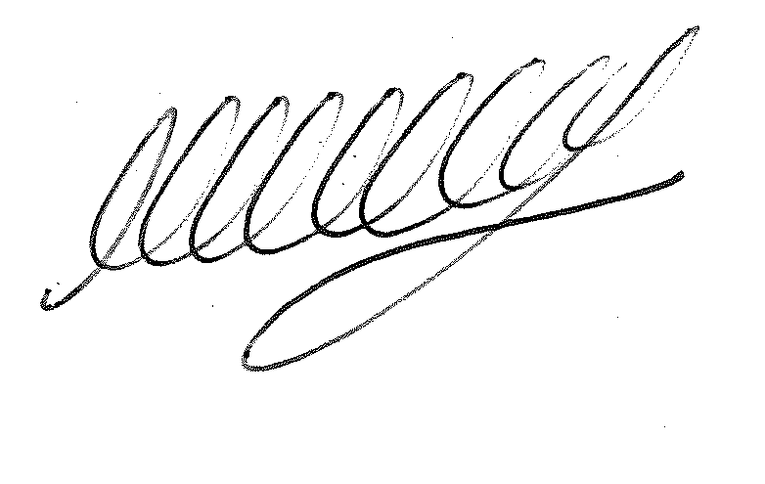

SIGNED DATE: 29th August 2023

M WELLS - TOWN CLERK

*Copies of correspondence circulated to Councillors with this agenda, which will be considered at the meeting.

