
6th June 2023

To Members of the Planning & Environment Committee

Cllrs Brooke (Ex Officio), U Arnold, Evans, Kelly, Kennedy, Simmons, West.

Cc: All other members of the Council for information.

Dear Councillor,
You are hereby summoned to attend a meeting of the Planning & Environment Committee which will be held in the Riverside Community Centre on Monday 12th June 2023 at 6:15pm for the purpose of transacting the business as set out on the agenda below.

AGENDA

PL.23/72 Apologies for absence:
To receive and consider for acceptance, apologies for inability to attend.

PL.23/73 Declarations of Interest and Requests for Dispensations
To declare any disclosable pecuniary interests or any other interest which members may have in the following agenda items and consider any dispensation requests.

**Public Participation:
We welcome the public to attend meetings and invite comments or questions regarding any of the agenda items. The Committee, at the Chair’s discretion, sets aside a period of time for this at the commencement of the meeting.

PL.23/74 Minutes:
i) To agree as a correct record and approve the minutes of the meeting of 30th May 2023 (*copy enclosed).
ii) To receive any update(s) on actions/items from the previous meeting.

PL.23/75 Standing Item – Climate and Ecology Emergency:
To note the Council Declaration and to embed the climate and ecology emergency declaration across all Council services, activities, plans and other relevant work, considering the environmental impact of decisions, ensuring a fully integrated approach to mitigating the impact of climate change.

PL.23/76 Consideration of Planning Applications:

a) 23/00794/REM (Deferred Application) Approval of details for a dwelling (approval sought for appearance, landscaping, layout and scale); Self build plot 1, Marriott Way, Bovey Tracey (Observations due: TBC).

TDC Applications listed to 19.05.23:
b) 23/00783/FUL Two dwellings; The Garden Flat, 59B Fore Street, Bovey Tracey (Observations due: 13.06.23).

c) 23/00841/HOU Annexe to dwelling; 13A Fore Street, Bovey Tracey (Observations due: 14.06.23).

DNPA Applications listed to 26/05/23:
None.

TDC Applications listed to 26.05.23:
d) 23/00791/FUL Balcony to south with fire escape, and window change to door; 18 Torview, Flat 4 East Street, Bovey Tracey (Observations due: 21.06.23)

DNPA Applications listed to 02.06.23:
None.

TDC Applications listed to 02.06.23:
e) 23/00771/HOU Single storey extension to rear and alterations including annex; The Bibbery, Higher Bibbery, Bovey Tracey (Observations due: 23.06.23)

f) 23/00803/FUL Proposed storage building; Unit 2, Roundhead Road, Heathfield Industrial Estate, Bovey Tracey (Observations due: 23.06.23)

g) 23/00905/HOU Proposed extension; The Cottage, 14 Sett Close, Bovey Tracey (Observations due: 23.06.23)

PL.23/77 Applications Delegated to the Town Clerk (to note):
None.

PL.23/78 Planning Decisions:

- Approvals:
TDC:
i) 22/01562/FUL Change of use from car showroom/garage (sui generis) to hot food takeaway (sui generis) together with installation of extraction and ventilation equipment, replacement shopfront and external alterations at rear; Dartmoor Garage, Station Road, Bovey Tracey (Observations: No objection, subject to: i) further consideration being given to reducing the end of day opening hours so as not to impact on the neighbouring residents, ii) external signage to be appropriate for a Conservation Area and must not have a negative impact on the area/listed building(s) and iii) no adverse concerns being raised by DCC Highways as observations are made about the potential for parking/stopping outside on the Highway at peak times, noting that only 4 visitor spaces are being allocated.
ii) 23/00557/REM Approval of details for a dwelling (approval sought for appearance, layout, landscaping and scale); Self build plot 7, Marriott Way, Bovey Tracey (Observations: No objection).

b) Refusals:
TDC:
iii) 23/00102/CLDE Certificate of lawfulness for existing use of barn and land as part of residential curtilage; Little Bovey Bungalow, Bovey Tracey (Observations: Noted, no observations issued).
iv) 21/02896/FUL Erection of a building to form two units of holiday accommodation; Moorwood, Bovey Tracey (Observations: Objection as the 2018 approval was conditioned to ensure that the dwelling is only occupied by persons connected with agriculture or forestry as the site is located where development would not normally be permitted).

DNPA:
None

PL.23/79 General Planning Matters brought forward by Councillors: (For information only)

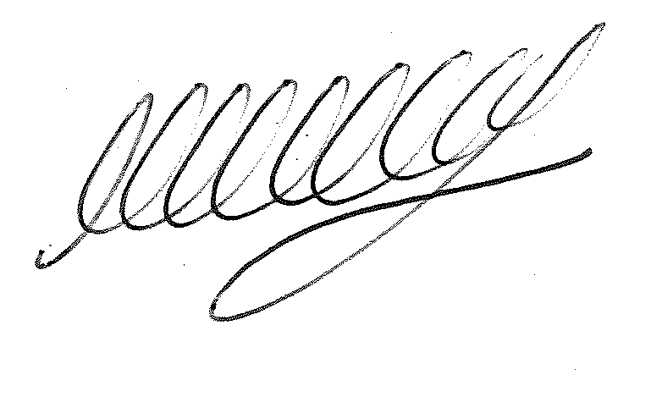

SIGNED ………………………………………………… DATE: 6th June 2023
M WELLS - TOWN CLERK

