
10th November 2020
Access to the Remote Meeting:
The press and public are welcome and are encouraged to attend meetings. The Town Council will however be meeting online using zoom software for the foreseeable future to protect the public and members from spreading the virus. Public with a telephone line or an internet connection can still join the meetings via the links below:

Join Zoom Meeting:
https://us02web.zoom.us/j/81197143710?pwd=NmJyWTMwQU9odUJZaU5WOUIzY0F2QT09

Meeting ID: 811 9714 3710
Passcode: 348660

Find your local number: https://us02web.zoom.us/u/kfzsAVNFg Note: Calls are charged at zoom rates and are payable by the user so please check before joining. More information at http://zoom.us/zoomconference/rates

Under ‘The Openness of Local Government Bodies Regulations 2014’ this meeting has been advertised as a public meeting and as such could be filmed or recorded by broadcasters, the media or members of the public.

* Members of the public are invited to ask questions or raise issues relevant to the work of the Council. The overall time available for this session is restricted to 15 minutes unless the Chair decides otherwise. Please note: questions to be submitted in writing, to arrive via email at the Council Office by 12 noon on the day of this meeting.

Dear Councillor,

You are hereby summoned to attend a remote meeting of Bovey Tracey Town Council on Monday 16th November 2020 at 7.00pm for the purpose of transacting the business as set out on the agenda below.

AGENDA

FC.20/58. Apologies for absence
To receive and consider for acceptance, apologies for inability to attend.

FC.20/59. Declarations of Interest and Requests for Dispensations
To declare any disclosable pecuniary interests or any other interest which members may have in the following agenda items and consider any dispensation requests.

FC.20/60. Minutes
i) To receive and resolve as a correct record the minutes of the Full Council meeting held on 21.9.20 (*copy enclosed).
ii) To receive an update(s) on any matters arising from the Full Council meeting.

FC.20/61. Standing Item – Climate Emergency:
To note the Council Declaration and to embed the climate emergency declaration across all Council services, activities, plans and other relevant work, considering the environmental impact of decisions, ensuring a fully integrated approach to mitigating the impact of climate change. The Council’s Climate Emergency Bovey & Heathfield Working Group leads and coordinates these activities.

The meeting will go out of session

FC.20/62. Reports from Key Bodies on Parish related matters:
To receive the reports (if any) from key bodies including:
i) Chaplain to the Council
ii) Police (*copy enclosed)
iii) County, District and Town Councillors
iv) Town Mayor’s Interests
v) Other outside bodies

FC.20/63. Questions and Statements by the Public
The Town Mayor will invite Members of the Public to ask questions or make statements (maximum 3 minutes per person).

The meeting will go back into session

FC.20/64. Business Raised by the Public:
To resolve to refer any business raised by the public in public discussion and any other matters or items of information from Councillors, to the appropriate Committee or to resolve to agree on any other action.

Committee Meeting Reports

FC.20/65. Recreation, Parks & Property Committee (RP&P) Committee:
i) To receive and adopt the minutes of the meeting held on 19.10.20 (*draft copy enclosed). A brief verbal summary highlighiting key issues will be provided.

FC.20/66. Finance, Resources & General Purposes (FR&GP) Committee:
i) To receive and adopt the minutes of the meeting held on 02.11.20 (*draft copy enclosed). A brief verbal summary highlighiting key issues will be provided.

FC.20/67. Planning & Environment Committee:
i) To receive and adopt the minutes of the meetings held on 05.10.20 (*copy enclosed),
19.10.20 & 02.11.20 (draft copy enclosed). A brief verbal summary highlighiting key issues will be provided.

Items for Consideration

FC.20/68. Bovey Tracey Community Centre:
i) To receive and approve contract payments/variations as appropriate (*copy to be circulated).

FC.20/69 Emergency Planning

To receive an update from Cllr Brooke and consider any further action as appropriate following the ‘in-principle’ agreement to proceed with developing a plan.

Working Group Updates

FC.20/70 Bovey Parish Covid-19 Action Group:
To receive and consider any updates or actions in relation to the Bovey Parish Covid-19 Action Group.

FC.20/71 Bovey Parish Neighbourhood Plan:
To receive and consider any updates or actions in relation to the Bovey Parish Neighbourhood Plan.

FC.20/72 Climate Emergency Bovey & Heathfield (CEBH):
i) To receive and consider any updates or actions in relation to the Climate Emergency Declaration.
ii) To receive and note current actions of the CEBH group (*copy enclosed)

FC.20/73 Exclusion of the Public, including the Press:

To give consideration to resolve the following:

That under Section 100 (A) of the Local Government Act 1972, in view of the confidential nature of the business about to be transacted in item FC.20/74, it is advisable in the public interest that the public (including the press) be temporarily excluded and they are instructed to withdraw.

FC.20/74 Grant of Option for Brimley Field, Bovey Tracey:
To receive the Option Agreement and Overage Deed in respect of land known as Brimley Field and consider authorising the Town Mayor and Town Clerk to sign on behalf of the Council (copy enclosed for Councillors only).

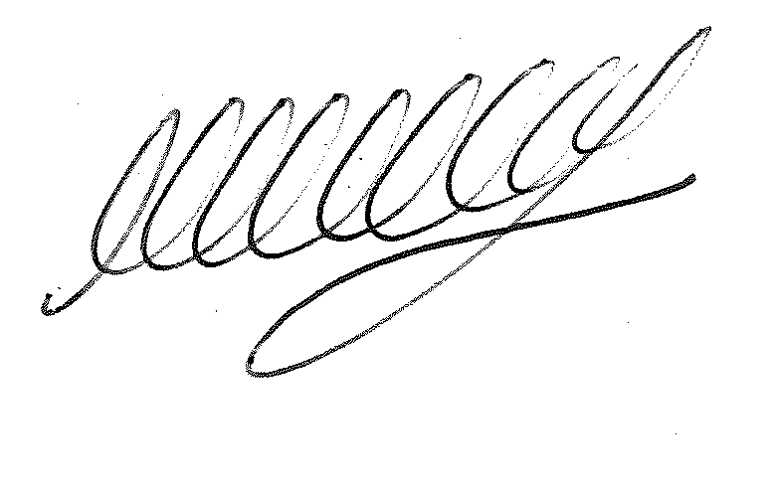

SIGNED DATE: 10th November 2020
M WELLS – TOWN CLERK

*Copies of any correspondence circulated to Councillors with this agenda, which will be considered at this meeting.

Councillors:

- You must declare the nature of any disclosable pecuniary interests (under the Localism Act 2011, this means the interests of your spouse, or civil partner, a person with whom you are living with as husband and wife or a person with whom you are living as if you are civil partners). You must also disclose any personal interest.

- You must disclose your interest in an item whenever it becomes apparent that you have an interest in the business being considered.

- Make sure you say what your interest is, as this has to be included in the minutes. (For example, ‘I have a disclosable pecuniary interest because this planning application is made by my husband’s employer’).

- If your interest is a disclosable pecuniary interest, you cannot participate in the discussion, cannot vote and must leave the room unless you have obtained a dispensation from the Clerk.

* Members of the Public:

- Individual speakers are restricted to 3 minutes and are asked not to repeat points that have been made previously.

- Whilst meetings are being undertaken remotely, potential contributors are asked to email the Town Clerk before the meeting with their question so that the question can be responded to at the meeting and the session can be programmed effectively.

- Public participation is not part of the formal meeting of the Council, however a note will be made of the matters raised and recorded within the minutes of the meeting

