
13th October 2020

Access to the Remote Meeting

The press and public are welcome and are encouraged to attend meetings. The Town Council will however be meeting online using zoom software for the foreseeable future to protect the public and members from spreading the virus. Public with a telephone line or an internet connection can still join the meetings via the link below:

https://us02web.zoom.us/j/85396088187?pwd=dDhnZHE2TkY5aWRkYTFCaTJzMi9KUT09

Meeting ID: 853 9608 8187
Passcode: 130989

Find your local number: https://us02web.zoom.us/u/kdpkVkGBpT Note: Calls are charged at zoom rates and are payable by the user. More information at http://zoom.us/zoomconference/rates

To Members of the Recreation, Parks & Property Committee

Cllrs Brooke (Ex Officio), Allen, J. Arnold, Cole, Elphick, Kerswell & Morgan-West.

Cc All other members of the Council for information.

Dear Councillor,

You are hereby summoned to attend a virtual meeting of the Recreation, Parks & Property (RP&P) Committee on Monday 19th October 2020 at 7pm for the purpose of transacting the business as set out below.

AGENDA

Interest to be declared: In accordance with the Code of Conduct, Members are invited to declare any personal or disclosable pecuniary interests, including the nature and extent of such interests, they may have in items to be considered at this meeting. Members are also reminded that any change to their Declaration of Interests must be notified to the Monitoring Officer at Teignbridge District Council within 28 days of the change.

RP&P.20/32 Apologies for Absence:

**Public Participation:

The Committee, at the Chairman’s discretion, sets aside a short period of time at the commencement of the meeting when the public can ask questions or make statements regarding agenda items.

RP&P.20/33 Minutes:

To agree as a correct record and approve the minutes of the meeting of 13th July 2020 (*copy enclosed).

RP&P.20/34 Standing Item – Climate Emergency:

To note the Council Declaration and to embed the climate emergency declaration across all Council services, activities, plans and other relevant work, considering the environmental impact of decisions, ensuring a fully integrated approach to mitigating the impact of climate change.

RP&P.20/35 Litter Bins – Council Owned Parks & Open Spaces (Deferred item RP&P.20/26):

To receive feedback from the Town Clerk and consider any further action as appropriate.

RP&P.20/36 Saving Devon Treescapes (Deferred item RP&P.20/27):

To receive consultation feedback and consider action as appropriate (*copy enclosed).

RP&P.20/37 Town Council Artefacts (Deferred item RP&P. 20/30):

To consider action as appropriate in relation to the relocation of items (to be circulated).

RP&P. 20/38 Bovey Tracey Football Club:

To receive correspondence on behalf of Bovey Tracey Football Club and consider appropriate action in relation to points 1-4 as highlighted in the letter (*copy enclosed).

RP&P.20/39 Bovey Tracey Players – Football Pavilion Premises (Recreation Ground):

To receive correspondence on behalf of Bovey Tracey Players and consider appropriate action in relation to their request (*copy enclosed).

RP&P.20/40 Formation of a ‘Friends of Mill Marsh Park’ Group:

To receive a verbal update from Cllr Cole.

RP&P.20/41 Playing Field – Little Bovey, Heathfield:

To consider a request on behalf of the Greater Horseshoe School to renew their current agreement for the use of the Playing Field on Little Bovey Lane, Heathfield.

RP&P.20/42 Quantified Tree Risk Assessment (QTRA)

To receive the QTRA report and consider action as appropriate (*copy enclosed).

RP&P.20/43 Matters brought forward by the Town Clerk & Councillors: (for information)

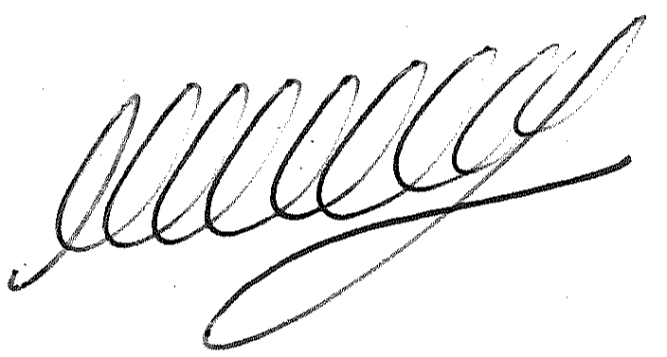

SIGNED DATE: 13th October 2020

M WELLS - TOWN CLERK

*Copies of correspondence circulated to Councillors with this agenda, which will be considered at the meeting.

