29th August 2023

To Members of the Planning & Environment Committee

Cllrs Brooke (Ex Officio), U Arnold, Evans, Kelly, Kennedy, Simmons, West.

Cc: All other members of the Council for information.

Dear Councillor,
You are hereby summoned to attend a meeting of the Planning & Environment Committee which will be held at the Riverside Community Centre on Monday 4th September 2023 at 6:15pm for the purpose of transacting the business as set out on the agenda below.

AGENDA

PL.23/91 Apologies for absence:
To receive and consider for acceptance, apologies for inability to attend.

PL.23/92 Declarations of Interest and Requests for Dispensations
To declare any disclosable pecuniary interests or any other interest which members may have in the following agenda items and consider any dispensation requests.

**Public Participation:
We welcome the public to attend meetings and invite comments or questions regarding any of the agenda items. The Committee, at the Chair’s discretion, sets aside a period of time for this at the commencement of the meeting.

PL.23/93 Minutes:
i) To agree as a correct record and approve the minutes of the meeting of 10th July 2023 (*copy enclosed).
ii) To receive any update(s) on actions/items from the previous meeting.

PL.23/94 Standing Item – Climate and Ecology Emergency:
To note the Council Declaration and to embed the climate and ecology emergency declaration across all Council services, activities, plans and other relevant work, considering the environmental impact of decisions, ensuring a fully integrated approach to mitigating the impact of climate change.

PL.23/95 Consideration of Planning Applications:

DNPA Applications listed to 14.07.23:
None.

TDC Applications listed to 14.07.23:
a) 23/00032/CERT (To note) Appeal against the refusal of 23/00184/CLDE; Certificate of lawfulness for existing use of building as dwelling (Observations: Application noted).

b) 22/01386/FUL (To note Application Withdrawn) Dwelling in the garden; 30 Kiln Close, Bovey Tracey (Observations: No objection, however clarification should be sought as the Bat Survey that has been commissioned mentions the building has an extension when it is clearly a separate building).

c) 23/00013/REF (To note) Appeal against the refusal of 21/02681/FUL; Retention of use of light industrial building (Class E) as educational use (Class F1) and insertion of new windows to first floor of side elevation (Observations: No objection).

DNPA Applications listed to 18.08.23:

d) 0378/23 Stable and fodder store to mirror existing stable and twin access track with turning/parking; Bracken Hill, Haytor Road, Bovey Tracey (Observations due: 05.09.23)

TDC Applications listed to 18.08.23:
None.

DNPA Applications listed to 25.08.23:
None.

PL.23/96 Applications Delegated to the Town Clerk (to note):
a) 23/01116/TPO G002 Pedunculate Oak, selective lateral reductions of between 2.5 – 3m. G003 Common Ash, Fell. T002 Common Ash, Fell. T003, Common Ash, Fell. T007 Willow, Crown raise to 6m. T008 Pedunculate Oak, Crown raise to 6m and lateral reduction by 1.5m; Verge south side, footpath from Bradley Road to Rendells Meadow (Observations: Referred to Arboricultural Officer).
b) 23/01525/TPO G5 Ash and Oak remove to ground level, T3 Ash remove to ground level, T1 Oak remove deadwood, T2 Oak remove deadwood, T4 Oak remove deadwood; Brookfield House, Challabrook Lane, Bovey Tracey (Observations: Referred to Arboricultural Officer).
c) 23/01546/TPO T1 Quercus robur, fell: 1 Brow Hill, Heathfield, Bovey Tracey (Observations: Referred to Arboricultural Officer).
d) 23/01562/TPO T1 Oak, fell. T2 Beech, fell. T3 Beech Cluster, fell. T4 Scotts Pine, fell. T5 small whip cluster, fell. T6 Scotts Pine, fell. T7 Scotts Pine, fell. T8 Beech Sapling, fell. T9 Scotts Pine, fell. T10 Silver Birch, fell. T11 – 13 Small cluster saplings, fell. T14 Beech, fell. T15 Beech, fell. T16 Beech, fell. T17 Beech, limb removal. T18 Beech crown raise of 5 lower limbs protruding over road. T19 Beech sapling, fell. T20 Beech crown raise removing 5 lower limbs protruding towards road. T21 Scots Pine, fell. T22 Beech sapling cluster, fell. T23 Beech, prune lowest branch to collar on main stem. T24 Beech prune to collar on main stem. T25 Beech, prune to collar on main stem. T26, Beech sapling, fell. T27 Beech, prune back 3 metres. T28 Beech, prune to collar. T29, Beech, fell. T30 Beech, prune to collar on main stem. T31 Holly, remove: Powerpark 38, Old Newton Road, Bovey Tracey (Observations: Referred to Arboricultural Officer).

PL.23/97 Planning Decisions:

- Approvals:
TDC:
i) 23/00771/HOU Single storey extension to rear and alterations including annex; The Bibbery, Higher Bibbery, Bovey Tracey (Observations: No objection).
ii) 22/02073/ADV Two fascia signs and refurbishment of existing totem sign; Dartmoor Garage, Station Road, Bovey Tracey (Observations: The current application is not supported due to all proposed signs being internally illuminated. Station Road frontage should not be lit and the courtyard could be lit as appropriate for a Conservation Area (e.g. lights facing the premises). Any lighting must not cause annoyance/disturbance to neighbouring residential properties).
iii) 23/00928/TPO The pruning of 12 trees and the felling of one tree; Land adjoining Indio House, Newton Road, Bovey Tracey (Observations: Referred to Arboricultural Officer).
iv) 23/01116/TPO (Split decision) G002 Pedunculate Oak, selective lateral reductions of between 2.5 – 3m. G003 Common Ash, Fell. T002 Common Ash, Fell. T007 Willow, Crown raise to 6m. T008 Pedunculate Oak, Crown raise to 6m and lateral reduction by 1.5m, (T003, Common Ash, Fell – refused); Verge south side, footpath from Bradley Road to Rendells Meadow (Observations: Referred to Arboricultural Officer).
v) 23/00905/HOU Proposed extension; The Cottage, 14 Sett Close, Bovey Tracey (Observations: No objection).
vi) 23/01387/TPO Multi stemmed Goat Willow, remove 3 stems; Land East of Monks Way NGR 281169 78801 (Observations: Referred to Arboricultural Officer).

DNPA:
vii) 0282/23 Refurbishment and extension to existing dwelling; Reddaford Water, Bovey Tracey (Observations: No objection).

b) Refusals:
TDC:
None.

DNPA:
None.

PL.23/98 20mph Community Self-Assessment Form (Tranche 2)
To receive a verbal update from the appointed Task & Finish Group and consider any further action if/as appropriate.

PL.23/99 Summer Recess Report
To receive and note the Summer Recess Report and observations issued (*copy enclosed).

PL.23/100 Environmental Policy (Deferred item: PL.23/69)
To review and consider a recommendation to Full Council to re-adopt the policy (*copy enclosed).

PL.23/101 General Planning Matters brought forward by Councillors: (For information only)

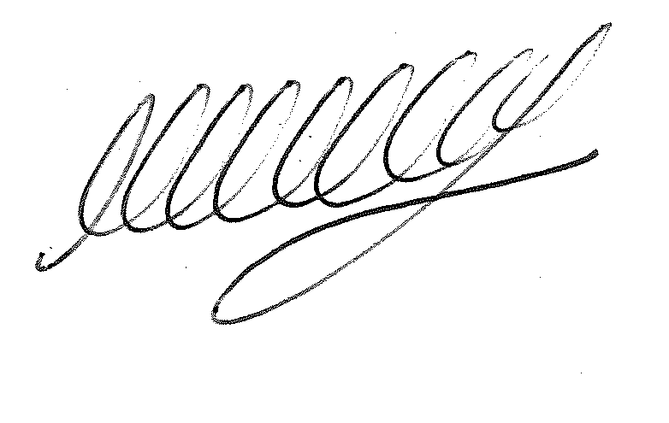

SIGNED ………………………………………………… DATE: 29th August 2023
M WELLS - TOWN CLERK

