6th June 2023

To Members of the Finance, Resources & General Purposes Committee

Cllrs Brooke (Ex Officio), Allen, Burton, Evans, Fletcher, Kennedy & Oldrieve.

Cc: All other Members of the Council for information.

Dear Councillor,

You are hereby summoned to attend a meeting of the Finance, Resources and General Purposes (FR&GP) Committee on Monday 12th June 2023 at 7.00 pm at the Riverside Community Centre for the purpose of transacting the business as set out on the agenda below.

AGENDA

FR&GP.23/34 Election of Chairperson of the Finance, Resources & General Purposes Committee for 2023/24
To elect a Committee Chairperson for 2023/24.

FR&GP.23/35 Election of Vice-Chairperson of the Finance, Resources & General Purposes Committee for 2023/24
To elect a Committee Vice Chairperson for 2023/24.

FR&GP.23/36 Apologies for absence
To receive and consider for acceptance, apologies for inability to attend.

FR&GP.23/37 Declarations of Interest and Requests for Dispensations
To declare any disclosable pecuniary interests or any other interest which members may have in the following agenda items and consider any dispensation requests.

**Public Participation:
We welcome the public to attend meetings and invite comments or questions regarding any of the agenda items. The Committee, at the Chairman’s discretion, sets aside a short period of time for this at the commencement of the meeting.

FR&GP.23/38 Minutes:
i) To agree as a correct record and approve the minutes of the meeting of 24th April 2023 (*copy enclosed).
ii) To receive any update(s) on actions/items from the previous meeting.

FR&GP.23/39 Standing Item – Climate Emergency:
To note the Council Declaration and to embed the climate emergency declaration across all Council services, activities, plans and other relevant work, considering the environmental impact of decisions, ensuring a fully integrated approach to mitigating the impact of climate change.

FR&GP.23/40 Accounts & Financial Statement:
To receive and approve:
i) Payment and receipt transactions between 1st April 2023 and 31st May 2023 (*copy enclosed)
ii) bank reconciliation between 1st April 2023 and 31st May 2023 (*copy enclosed)

iii) note the balances and borrowing as below:
General Account: £ 58,984.61 (as at 31.05.23)
Income/Precept A/C: £ 239,871.05 (as at 31.05.23)
Capital A/C: £ 50,803.97 (as at 31.05.23)
CIL A/C: £ 113,496.22 (as at 31.05.23)
National Lottery Grant: £ 35,500.43 (as at 31.05.23)
Charity Bank Invest (Rev) £ 85,746.41 (as at 31.05.23)
Cambridge & Counties (CiL) £ 85,000.00 (as at 31.05.23)
Nationwide Build Soc (CiL) £ 85,000.00 (as at 31.05.23)
B’hamshire Build Soc (Cap) £ 110,000.00 (as at 31.05.23)

Borrowing
Public Sector Works Loan £ - 427,586.16 (as at 31. 03.23)

FR&GP.23/41 Grant Application(s):
To receive and consider the following Grant Application:
i) Bovey Tracey Youth Action (*copy enclosed)
ii) Bovey Tracey Paradiso Arts Ltd (*copy enclosed)

FR&GP.23/42 Policies
i) To review the Treasury and Investment Policy and consider a recommendation to Full Council to re-adopt or any other action as appropriate (*copy enclosed)
ii) To receive a draft Community Infrastructure Levy (CiL) Groups Policy and consider a recommendation to Full Council to adopt or any other action as appropriate (*copy enclosed).

FR&GP.23/43 Town Council Financial Reserves
To receive and consider a report from the Assistant Town Clerk reviewing the position of the current level of reserves and agree any action as appropriate (*copy enclosed).

FR&GP.23/44 Internal Audit Report – Year End 31st March 2023:
To receive and consider the recommendation(s) and subsequent action(s) highlighted within the audit report (*copy enclosed).

FR&GP.23/45 Direct Debits and Standing Orders:
To receive and approve a list of Direct Debit/Standing Order payments (*copy enclosed).

FR&GP.23/46 Community Infrastructure Levy (CiL) Annual Report 2022/23:
i) To note the content of the CiL Annual Financial Report 2022/23 (*copy enclosed)
ii) To approve the publication of the report in accordance with regulation 62A of the Community Infrastructure Levy (CiL) Regulations 2010 (as amended).

FR&GP.23/47 Mill Marsh Park Play Area Redevelopment - Appointment of Project Manager
To consider approval of the appointment of Company B to provide Project Management for the redevelopment of Mill Marsh Park Play Area (*copy enclosed).

FR&GP.23/48 Public Toilets – Contract Cleaning
To receive and consider approval of an increase in cleaning costs from 1st May 2023 as follows or to agree alternative action as appropriate:

2022/23 2023/24
Station Road Public Toilets £648.00 pm plus vat £712.80 pm plus vat
Recreation Ground Public Toilets £249.34 pm plus vat £274.27 pm plus vat

FR&GP.23/49 Bank Mandate
To approve the following amendments to existing bank mandates:
Removals: Cllrs Bradshaw, Gribble, Mills
Additions: Cllrs Evans, Kennedy, Oldrieve
FR&GP.23/50 Matters brought forward by Councillors: (for information only).
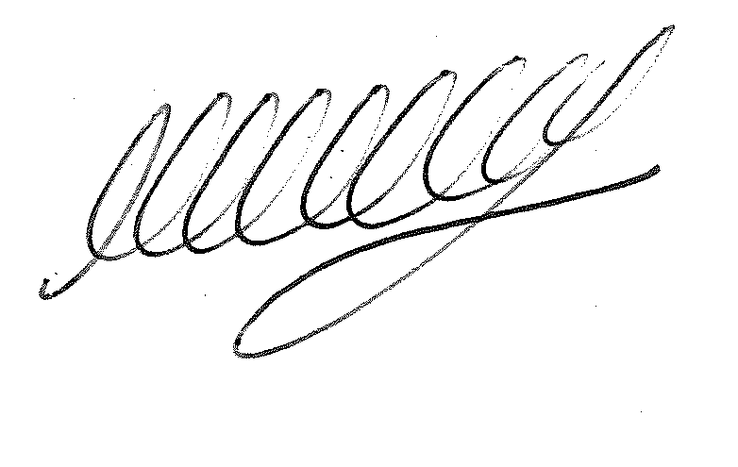

SIGNED DATE: 6th June 2023

M WELLS - TOWN CLERK

*Copies of correspondence circulated to Councillors with this agenda, which will be considered at the meeting.

