4th July 2023

To Members of the Planning & Environment Committee

Cllrs Brooke (Ex Officio), U Arnold, Evans, Kelly, Kennedy, Simmons, West.

Cc: All other members of the Council for information.

Dear Councillor,
You are hereby summoned to attend a meeting of the Planning & Environment Committee which will be held at the Riverside Community Centre on Monday 10th July 2023 at 6:15pm for the purpose of transacting the business as set out on the agenda below.

AGENDA

PL.23/80 Apologies for absence:
To receive and consider for acceptance, apologies for inability to attend.

PL.23/81 Declarations of Interest and Requests for Dispensations
To declare any disclosable pecuniary interests or any other interest which members may have in the following agenda items and consider any dispensation requests.

**Public Participation:
We welcome the public to attend meetings and invite comments or questions regarding any of the agenda items. The Committee, at the Chair’s discretion, sets aside a period of time for this at the commencement of the meeting.

PL.23/82 Minutes:
i) To agree as a correct record and approve the minutes of the meeting of 12th June 2023 (*copy enclosed).
ii) To receive any update(s) on actions/items from the previous meeting.

PL.23/83 Standing Item – Climate and Ecology Emergency:
To note the Council Declaration and to embed the climate and ecology emergency declaration across all Council services, activities, plans and other relevant work, considering the environmental impact of decisions, ensuring a fully integrated approach to mitigating the impact of climate change.

PL.23/84 Consideration of Planning Applications:

DNPA Applications listed to 09.06.23:
None.

TDC Applications listed to 16.06.23:
a) 23/00984/FUL Conversion of existing residential building used for purposes ancillary to Heatherside to use as a dwelling; 18 Pottery Road, Bovey Tracey (Observations due: 20.07.23)

b) 23/01070/FUL Change of use from former parking/storage area to café and associated buildings; The Mill, St Johns Lane, Bovey Tracey (Observations due: TBC)

c) 23/00807/NPA (Note: Application withdrawn) Application for prior approval under Part 3, Class G of the General Permitted Development (England) Order 2015 (as amended) for Change of use from Class E (Offices) to resdiental; 53 Fore Street, Bovey Tracey.

DNPA Applications listed to 16.06.23:
None.

TDC Applications listed to 23.06.23:

d) 23/01106/REM Approval of details for a dwelling pursuant to planning permission 17/01821/MAJ (approval sought for appearance, landscaping, layout and scale); Self Build Plot 6, Marriott Way, Bovey Tracey (Observations due: 20.07.23)

e) 23/00794/REM (Note: Application withdrawn) Approval of details for a dwelling (approval sought for appearance, landscaping, layout and scale); Self Built Plot 1, Marriott Way, Bovey Tracey.

DNPA Applications listed to 23.06.23:
None.

TDC Applications listed to 30.06.23:

f) 23/01150/HOU Single storey side and rear extensions and replacement garage; St Martins, Bradley Road, Bovey Tracey (Observations due: TBC)

g) 23/01165/REM Approval of details for a dwelling pursuant to planning permission 17/01821/MAJ (approval sought for appearance, landscaping, layout and scale); Self Build Plot 8, Marriott Way, Bovey Tracey (Observations due: TBC)

DNPA Applications listed to 30.06.23:

h) 0282/23 Refurbishment and extension to existing dwelling; Reddaford Water, Bovey Tracey (Observations due: TBC)

i) 0212/23 (Note: Application withdrawn) Alterations and extensions; 1 Ullacombe Cottages, Haytor Road, Bovey Tracey.

PL.23/85 Applications Delegated to the Town Clerk (to note):
a) 23/00363/TPO Treetops, Newton Road, Bovey Tracey: A1 Rhododendron, Willow, Elder and Holly: Coppice all marked stems, max diameter of cut 10cm. T1 Holm Oak, remove single 10cm branch. G1 Three Willow, fell. G2 Two Yew, cut back overhanging branches, max diameter of cut 25mm. T2 Cypress, reduce stem to a height of 2.5m to for part of a hedge. G3 Two Oaks, cut back branches over driveway, max diameter of cut 50mm (Observations: Refer to TDC Arboricultural Officer).

b) 23/00928/TPO Land adjoining Indio House, Newton Road, Bovey Tracey: The pruning of 12 trees and the felling of one tree: T01 Birch, crown lift. T02 Ash, fell. G03 Sycamore x 5, crown lift to 3m. T04 Sycamore, crown lift to 3m. G05 Sycamore x 5, crown lift to 3m. G05a Sycamore, remove one damaged branch (Observations: Refer to TDC Arboricultural Officer).

PL.23/86 Planning Decisions:

- Approvals:
TDC:
i) 23/00563/HOU Decking to rear; 4 Becket Road, Bovey Tracey (Observations: No objection).
ii) 22/01627/HOU Single storey rear and side extension, rear raised patio, removal of front boundary wall and fence and paving of front garden, replacement of northern boundary fence with Devon hedgebank; 15 St Peters Close, Bovey Tracey (Observations: No objection).
iii) 23/01067/AGR Agricultural storage building; Little Bradley Farm, Bovey Tracey (Observations: None issued)
iv) 22/01892/LBC Replacement roof tiles; Dolphin Hotel, Station Road, Bovey Tracey (Observations: No objection, subject to the District Council’s Conservation Officer raising no concerns).

DNPA:
v) 0494/22 Enhanced replacement woodland centre; Yarner Wood, Bovey Tracey (Observations: No objection)

b) Refusals:
TDC:
vi) 23/00747/NPA (cannot be determined under permitted development) 2 Station Road, Bovey Tracey; Application for prior approval under Part 3, Class MA and paragraph W of the GPDO for a change of use of ground floor to residential accommodation (Observations: Objection to the loss of a business premise as a contravention to the Bovey Parish Neighbourhood Development Plan, in particular objective B&E01 (the business premises in the core retail area are retained for business use) and policy B&E1. The core retail area (as defined in the NDP) is Station Road, Fore Street and Town Hall Place. In addition, policy B&E2 (proposals which require permission for business premises within the Parish to sub-divide its existing building will be supported only where: i) it can be shown that the existing business is not viable and ii) its premises have been widely marketed, at a market price, over a continuous period of at least 12 months).

DNPA:
None

PL.23/87 20mph Community Self-Assessment Form (Tranche 2)
To consider a response to the survey (*copy enclosed).

PL.23/88 Recess Arrangements for 2023 Summer Recess Period (11th July – 3rd September):
To discuss and agree a method of responding to any applications during the summer recess period.

PL.23/89 Environmental Policy (Deferred item: PL.23/69)
To review and consider a recommendation to Full Council to re-adopt the policy (*copy enclosed).

PL.23/90 General Planning Matters brought forward by Councillors: (For information only)

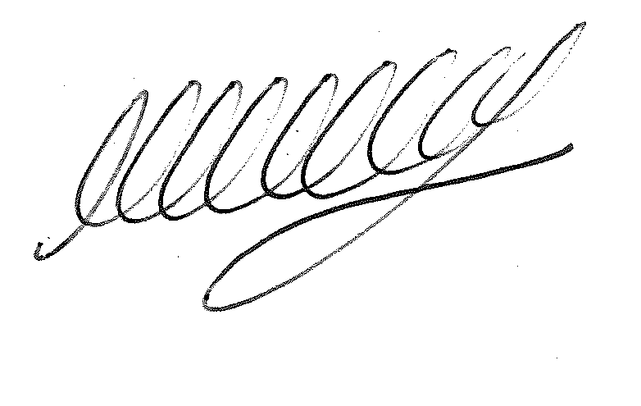

SIGNED ………………………………………………… DATE: 4th July 2023
M WELLS - TOWN CLERK

